**PRACTICAL NO : 03**

**Title :** Creating an Application in SalesForce.com using Apex programming Language

# STEPS TO CREATE AN APPLICATION :

**Step No 1: Create new org:** [**https://developer.salesforce.com/signup**](https://developer.salesforce.com/signup)

**Step No 2: After signup, loging using following URL** [**https://login.salesforce.com/**](https://login.salesforce.com/)

## Step No 3: Login Page (Enter your credential to login)

1. Open Developer Console
2. File ---> New ---> Select Apex Class
3. Type below mentioned code public class FirstClass1

{

public static void firstMethod()

{

System.debug('WELCOME TO METIOE NASHIK');

}

}

# Note : you can write any code as application

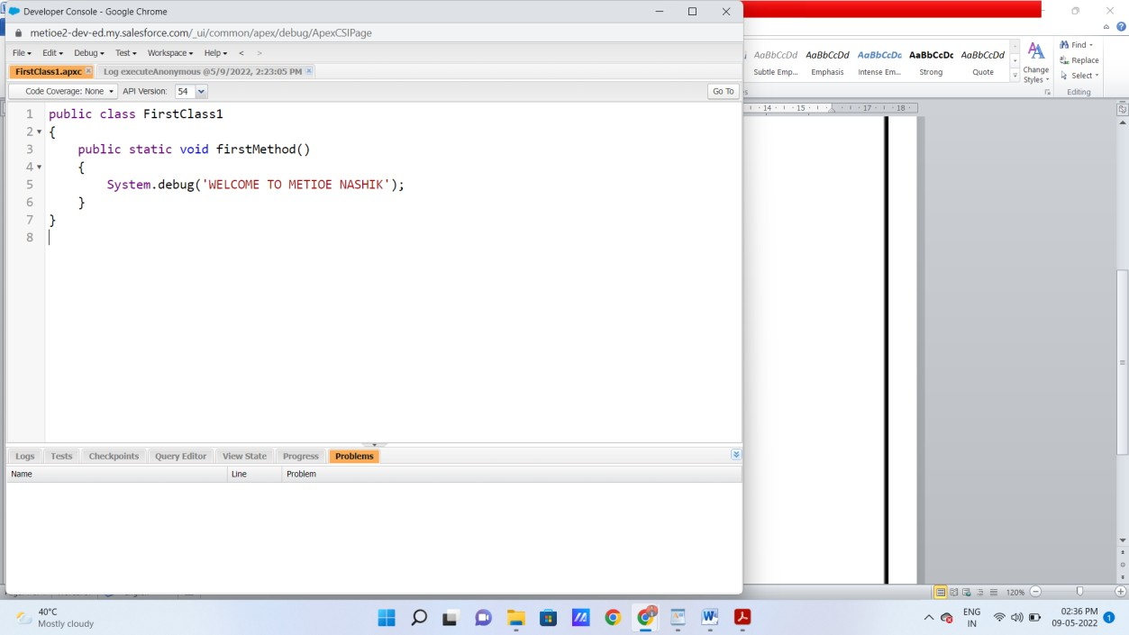

1. Click on Debug ---> Open Execute Acronymous Window
2. Type below code(Apex Code) FirstClass1.firstMethod();

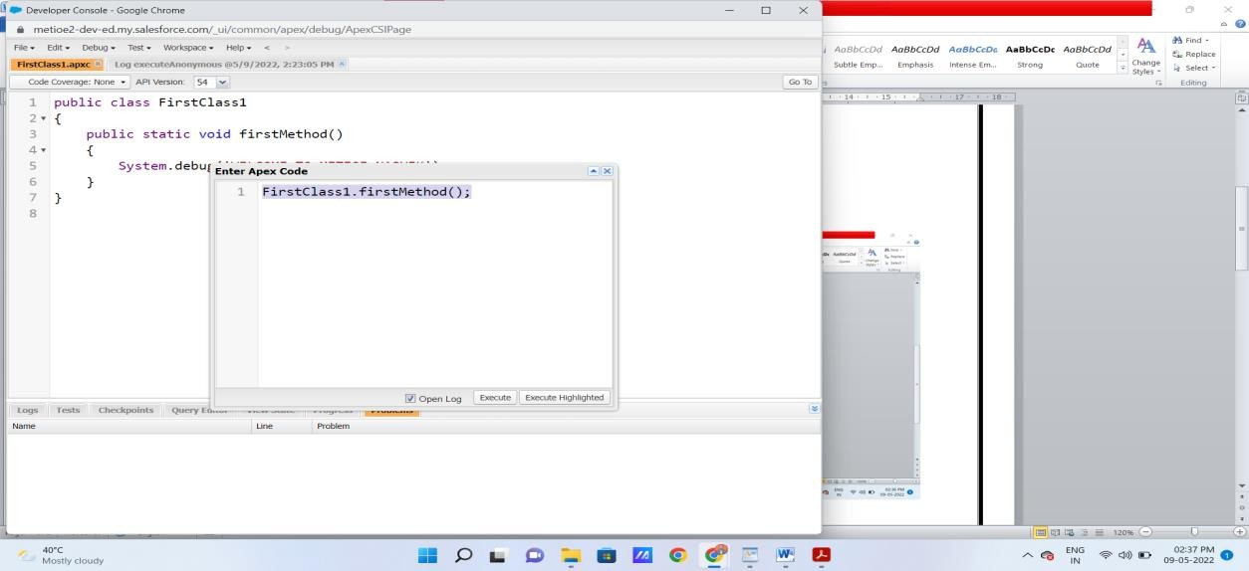

1. Click on Open log then Execute code
2. Click on Debug only (You will get output)

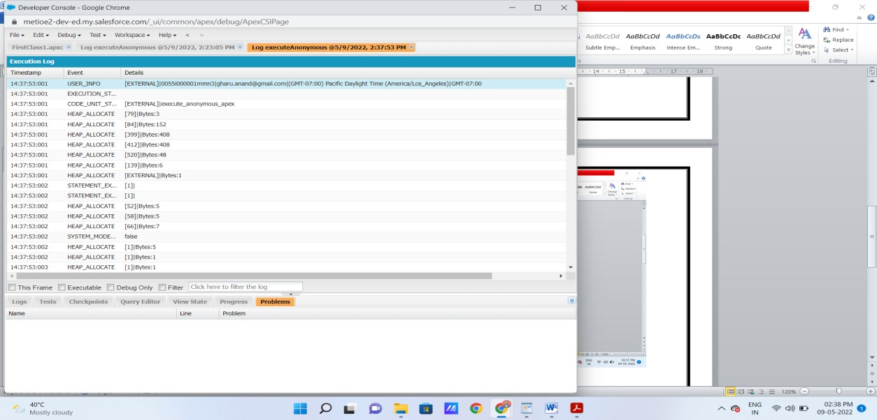

**Output :**

